

### *Message*

***from***

***The Honourable Kim Beazley, AC***

***Governor of Western Australia***

***for***

***Australian National Flag Association WA***

*Australian National Flag Day is an opportunity for individuals, community organisations, local authorities, businesses and schools to celebrate the anniversary of the Australian National Flag.*

*First flown on the 3rd September 1901, the flag was known back then as the Commonwealth blue ensign. Since Federation, we have gained a new sense of what it means to be Australian and these sentiments can always be found when we look upon our national flag today.*

*The flag unites us on every important occasion – whether in celebration or sorrow – and is a symbol of our national identity, the story of our past and of our future, and our diverse and multicultural society.*

*It is important to recognise that the Australian National Flag now sits alongside the Australian Aboriginal Flag and the Torres Strait Islander Flag as a collective symbol of our country.*

*I thank the Australian National Flag Association WA for the opportunity to share in the occasion of the 119th anniversary of the Australian National Flag. A day to reflect on the journey of our country so far, and all that we hope to achieve in the future.*

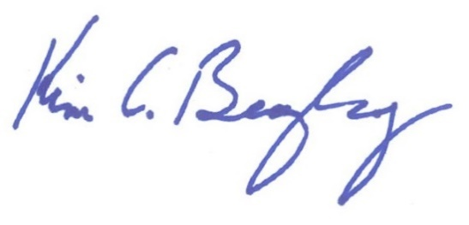

***GOVERNOR***